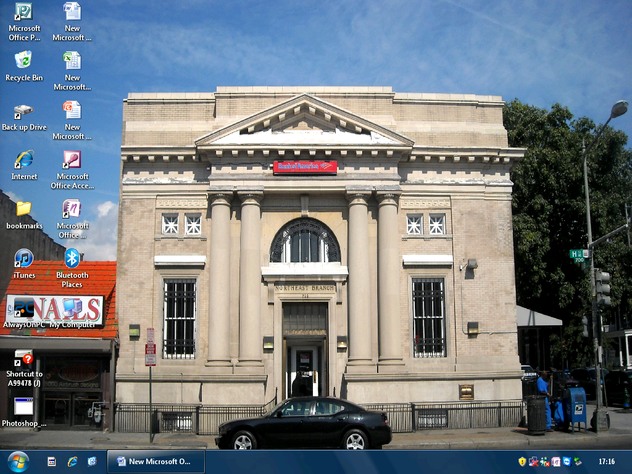

From your desktop go to the folder you want to zip.

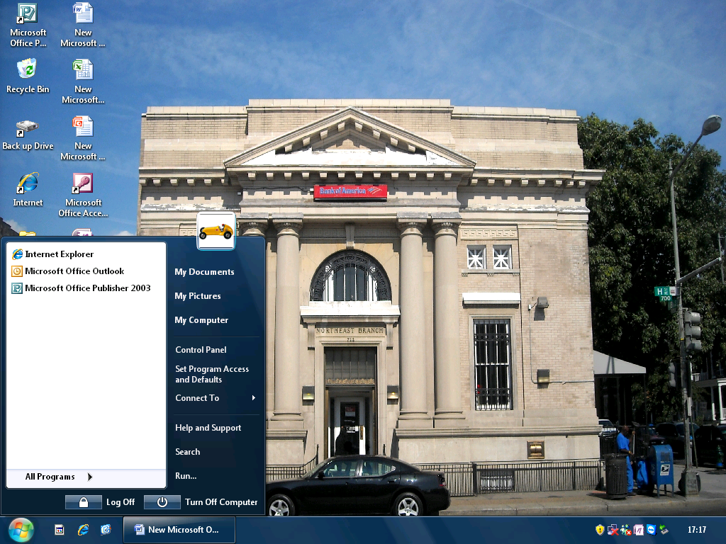

The folder I am going to zip is inside my computer so press on start then my computer

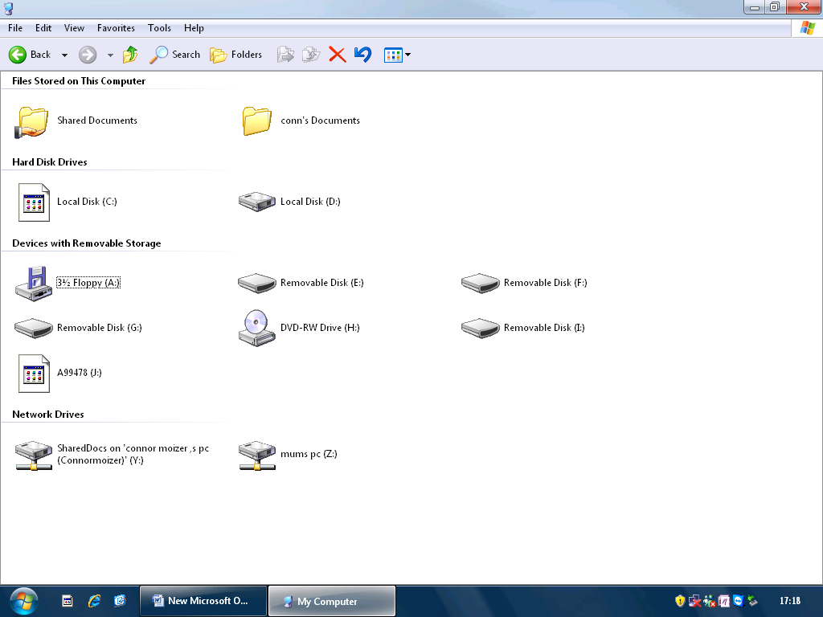

Then the A9478 USB drive

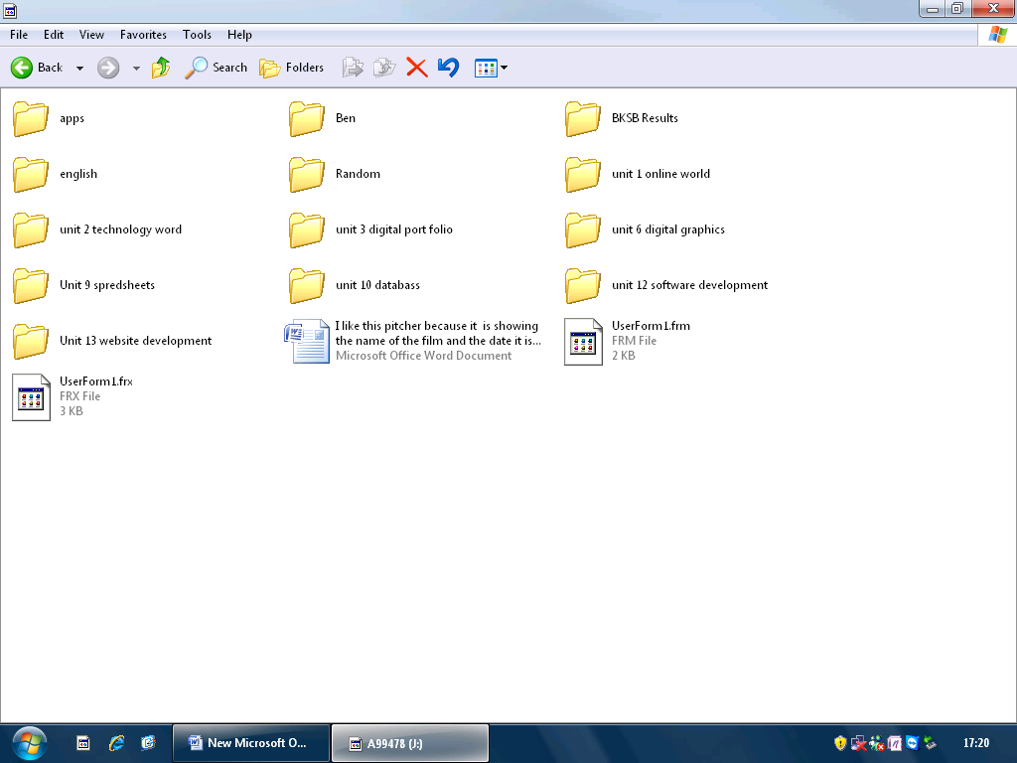

Then from hear I will zip one of the folders

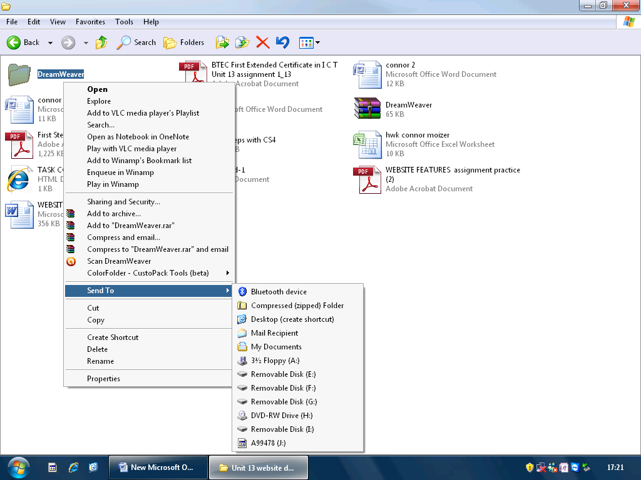

The folder I am going to zip is inside my unit 13 website development then right click on the folder

.

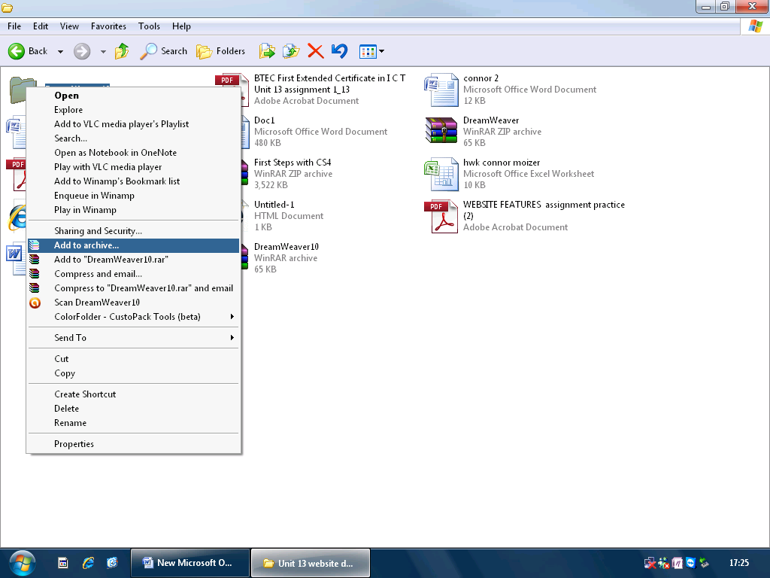my pc did not have zipper on so I used add to archive